**STEPS TO RUN DUAL AUTHENTICATION FIREWALL:**

1. Double click on daf.jar file or open with Java(TM) Platform SE.

If .jar file does not run then create a text file but change its extension to .bat and the edit the file with java -jar jarfilename.jar .

1. Now the popup file will open and after that the Login page will open up. Add login credentials if already registered or otherwise register.

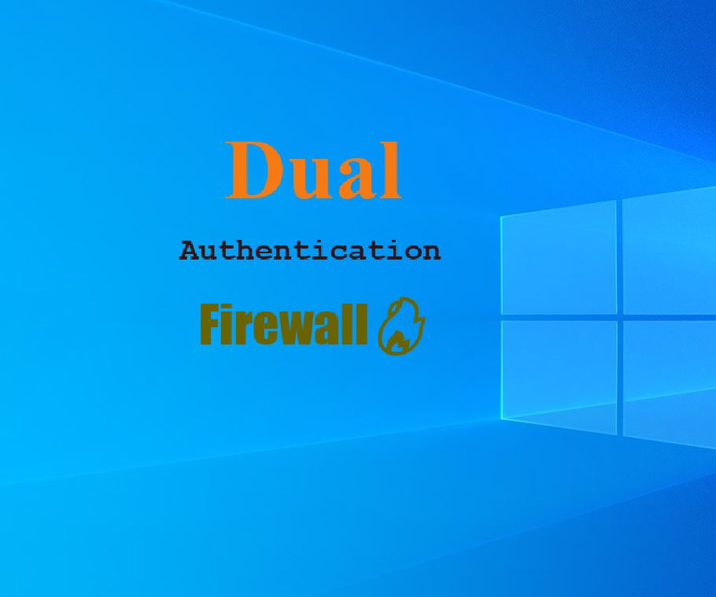

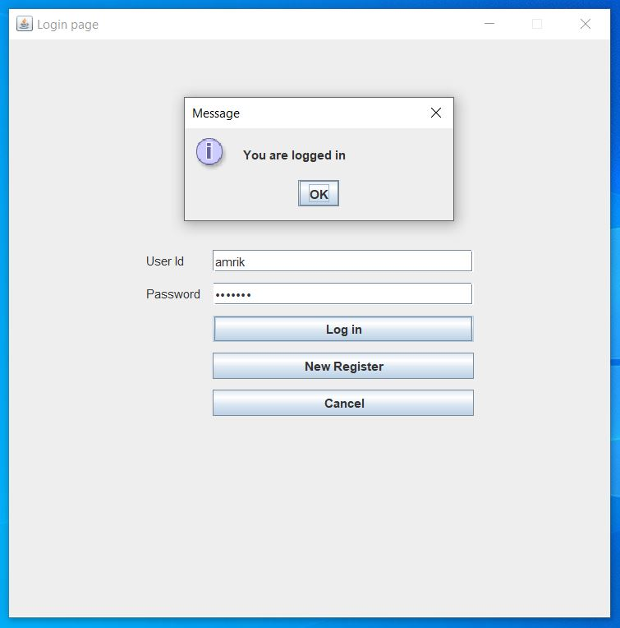

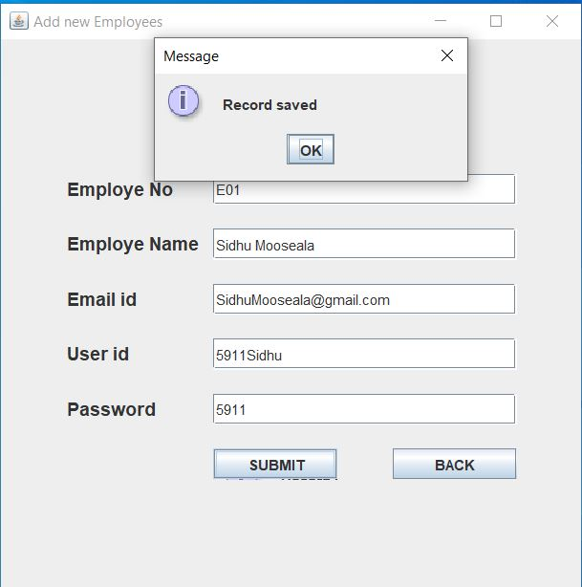

1. Now Manage IP page will be opened using which you can view the block list, add an IP Address to the Block list or remove an added one.

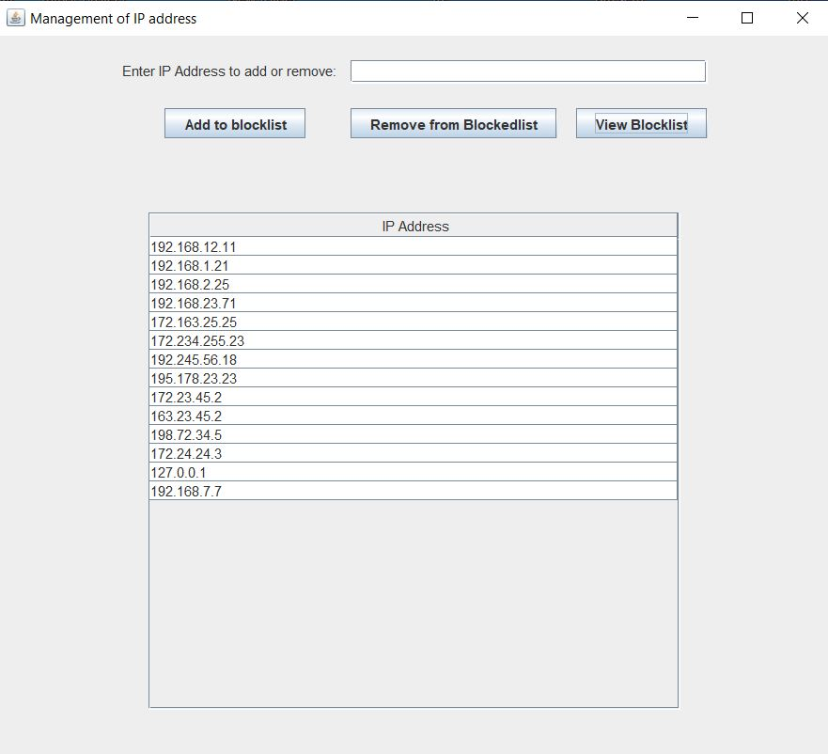

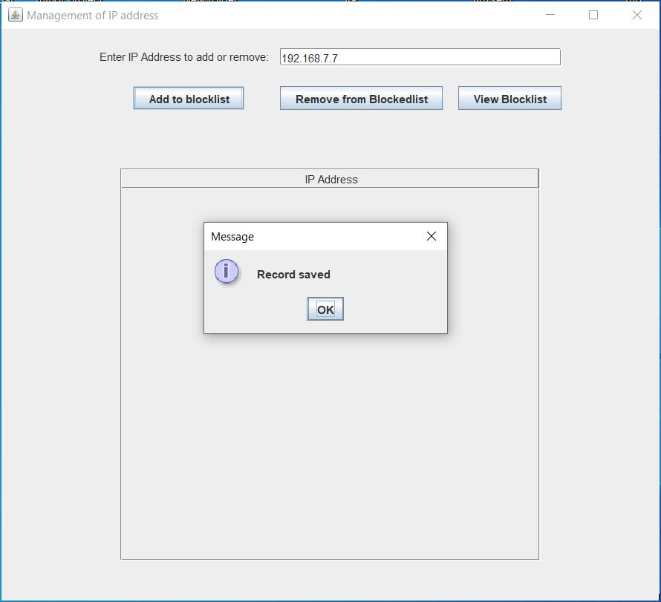

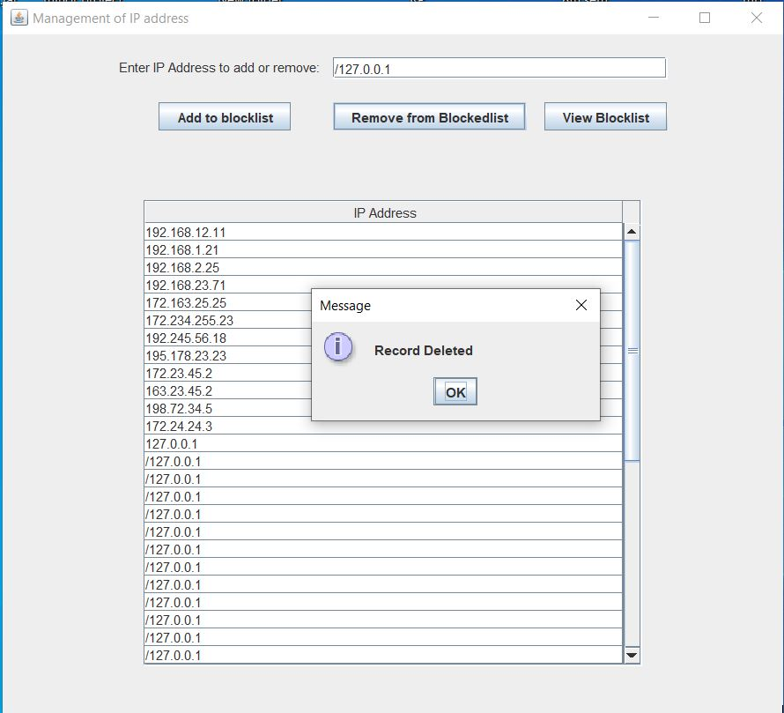

1. Since the firewall is running now on the local pc, so your pc will act as a server. Now you can request to the server through a computer connected to the server through wired LAN or from the server itself for testing. For that you need to open web browser and request the server using the IP of server along with port number by search so in the search bar. For example 192.168.1.0:8080. Now if you are an authorized client then you will receive a page otherwise not.

